Software Requirements Specification

for

MEDISYNC

Version 1.0 approved

Prepared by

Aryan Bhattacharjee(2105702)

Oishy Sur(21052436)

Lalkrishna Patel(21052994)

Nandini Das(21052599)

Riya Raj(21052238)

Nirmallya Dutta(2105212)

Ipshita Das(21051822)

Sharique Iqubal(21052790)

Kalinga Institute of Industrial Technology

04-09-2023

Table of Contents

Table of Contents ii

Revision History ii

1. Introduction 2

1.1 Purpose 2

1.2 Document Conventions 3

1.3 Intended Audience and Reading Suggestions 3

1.4 Product Scope 4

1.5 References 6

2. Overall Description 6

2.1 Product Perspective 6

2.2 Product Functions 6

2.3 User Classes and Characteristics 7

2.4 Operating Environment 7

2.5 Design and Implementation Constraints 7

2.6 User Documentation 8

2.7 Assumptions and Dependencies 8

3. External Interface Requirements 10

3.1 User Interfaces 10

3.2 Hardware Interfaces 13

3.3 Software Interfaces 15

3.4 Communications Interfaces 18

4. System Features 19

5. Other Nonfunctional Requirements 21

Appendix A: Glossary 23

Revision History

|  |  |  |  |
| --- | --- | --- | --- |
| **Name** | **Date** | **Reason For Changes** | **Version** |
|  |  |  |  |
|  |  |  |  |

# Introduction

## Purpose

* Creating a health tracking app or website which serves multiple

purposes, primarily aimed at helping individuals monitor and improve

their overall well-being. Here are some common purposes behind

developing such platforms.

* Personal Health Management: Health tracking apps enable users to

monitor various aspects of their health, including physical activity,

nutrition, sleep patterns, heart rate, and more. Users can set goals

and track their progress over time, which can motivate them to

make healthier lifestyle choices.

* Data Visualization: These apps often provide users with visual

representations of their health data through graphs, charts, and

trends. Visualizing progress can make it easier for users to

understand their patterns and identify areas for improvement.

* Motivation and Accountability: Health tracking apps can send

reminders, notifications, and achievements as users meet their goals.

This constant feedback loop can encourage individuals to stay

committed to their health objectives.

* Health Insights: By analyzing the collected data, these platforms can

offer insights into users' health trends and patterns. This can helpusers gain a better understanding of how their habits impact their

health and make informed decisions.

* Disease Management: For individuals with chronic conditions, health

tracking apps can help in managing their symptoms, medications,

and treatment plans. They can also facilitate communication

between patients and healthcare providers.

* Customized Recommendations: Based on the data gathered, some

apps use algorithms to provide personalized recommendations

tailored to an individual's health goals and needs.

* Community and Social Interaction: Many health tracking apps offer

social features, allowing users to connect with friends, family, or a

community with similar health interests. This social aspect can foster

support, encouragement, and healthy competition.

* Research and Analysis: Aggregated and anonymize data from these

apps can be used for research purposes, helping scientists and

healthcare professionals understand population health trends, study

the effectiveness of interventions, and improve public health

initiatives.

* Remote Monitoring: Health tracking apps can be valuable tools for

remote patient monitoring. Healthcare providers can remotely

monitor patients' health data and intervene if necessary, reducing

the need for frequent in-person visits.

* Preventive Care: By providing users with early warnings and insights

about potential health issues, these apps contribute to preventive

care, enabling individuals to take action before a problem becomes

severe.

* Integration with Wearable Devices: Many health tracking apps can

sync with wearable devices like fitness trackers and smartwatches,

allowing for real-time data collection and a more comprehensive

view of an individual's health.

* Education and Awareness: These platforms can educate users about

various health topics, promote healthy habits, and raise awareness

about the importance of leading a balanced lifestyle

## Document Conventions

* Structure: The SRS is organized into a logical structure that makes it easy for the reader to find the information they need. This typically includes sections on the purpose of the system, its requirements, and its design constraints.
* Format: The SRS is formatted in a consistent and readable style. This includes using clear headings and subheadings, white space, and fonts.
* Style: The SRS is written in a clear and concise style. This means avoiding technical jargon and using plain language whenever possible.

## Intended Audience and Reading Suggestions

Diverse range of users, each with varying levels of familiarity with

healthcare technology and terminology. It's important to cater to the

following categories:

● Patients and Users: Individuals who will be using the app to manage

their health, track medical information, schedule appointments, and

access healthcare resources.

● Healthcare Professionals: Doctors, nurses, and other medical

practitioners who may use the app to monitor patient progress,

access medical records, and communicate with patients.

● Administrative Staff: Personnel responsible for managing the app's

backend, maintaining databases, and ensuring smooth operations.

● Technical Support Teams: Individuals who will assist users with

technical issues, troubleshooting, and navigating the app.

● Stakeholders: Managers, investors, and decision-makers who need a

high-level understanding of the app's functionality, benefits, and

impact on healthcare services.

● Regulatory Authorities: Individuals who need to understand how the

app complies with healthcare regulations and data privacy laws.

**Reading Suggestions:**

● User Guide for Patients: Provide a comprehensive guide on how

patients can set up profiles, input health data, schedule

appointments, receive notifications, and interact with healthcare

providers through the app. Include step-by-step instructions,

screenshots, and FAQs.

● Clinical Usage Guide for Healthcare Professionals: Detail how medical

practitioners can access patient records, view test results,

communicate securely with patients, and make informed decisions

based on the app's data.

● Administrative Manual: Explain the backend processes, including

data management, user authentication, and system maintenance.

This section may target administrative staff and IT personnel.

● Troubleshooting and Support: Create a guide that addresses

common issues users might encounter and provides solutions.

Include contact information for technical support teams.

● Data Privacy and Security Overview: Provide an overview of the app's

security measures, data encryption, compliance with healthcare

regulations (such as HIPAA), and user data protection.

● Integration Guide: If applicable, offer guidance on integrating the

app with existing healthcare systems, electronic health record (EHR)

platforms, or other software used by healthcare organizations.

● Regulatory Compliance and Legal Information: Outline how the app

complies with relevant healthcare regulations and data protection

laws. Include disclaimers and terms of use.

* Benefits and Impact for Stakeholders: For stakeholders and decision-

makers, present a high-level overview of how the app improves

patient outcomes, enhances healthcare efficiency, and meets

strategic objectives.

## Product Scope

● Users can create accounts with personal information and medical

history.

● Implement secure authentication mechanisms.

**Health Data Tracking:**

● Users can input and track various health data, such as vital signs,

symptoms, medications, and allergies.

● Allow users to set health goals and track progress.

**Appointment Scheduling:**

● Provide a scheduling system for users to book appointments with

healthcare professionals.

● Send appointment reminders and notifications.

**Communication with Healthcare Providers:**

● Enable secure messaging between users and healthcare

professionals.

● Allow file sharing for medical reports and images.

**Electronic Health Records (EHR):**

● Create a digital repository for storing and accessing medical records.

● Ensure compliance with data privacy regulations (e.g., HIPAA).

**Medication Reminders:**

● Offer a feature to set medication schedules and receive reminders.

● Include information about dosage, frequency, and potential

interactions.

**Health Resources and Education:**

● Provide access to a library of health articles, resources, and

educational materials.

● Address a range of health topics and conditions.

**Emergency Information:**

● Allow users to store emergency contact information and medical

conditions.

● Provide quick access to this information from the app's main screen.

**Data Visualization and Analytics:**

● Display health data trends over time through charts and graphs.

● Offer insights into the user's health progress.

**User Notifications:**

* Send notifications for appointments, medication reminders, and

important health updates.

## References

HIPAA (Health Insurance Portability and Accountability Act) HIPAA

Apple Human Interface Guidelines

Fitbit Web API

Google Material Design Guidelines:

Apple HealthKit

Redox: Integration platform for healthcare.

Open Web Application Security Project (OWASP)

GDPR (General Data Protection Regulation)

# Overall Description

## 2.1 Product Perspective

The Healthcare Management App is a comprehensive software solution designed to streamline and enhance the management of medical records, prescriptions, medications, and healthcare-related information for users. It serves as a bridge between patients, doctors, and medical data, enabling seamless communication and accessibility to essential health-related information.It is a standalone, self-contained product designed to revolutionize the way patients manage their medical information. It is not a replacement for existing systems but a novel solution that empowers users to keep track of their medical reports, prescriptions, medications, and health-related data. The app serves as a digital repository and organizer, enhancing the communication and coordination between patients and healthcare providers.

The app is not a component of a larger system but a comprehensive software solution on its own. It interfaces with users' mobile devices (iOS and Android) and web browsers to provide accessibility and convenience. The app will ensure data security, user privacy, and regulatory compliance in handling healthcare information.

## 2.2 Product Functions

### The Healthcare Management App offers the following core functions:

### **User Registration and Authentication:** Users (patients) can create accounts using their personal information and a unique referral code from their respective doctors. The app ensures secure authentication and data protection.

### **Medical Records Storage:** Users can upload and store medical reports, prescriptions, and other health-related documents securely within the app. These records are organized chronologically for easy access.

### **Medication Tracking:** Users can log the medications they are taking, along with dosage and frequency. The app maintains a medication history for reference.

### **Referral Code Management:** Users can associate themselves with a specific doctor using a referral code. If users change doctors, they can update their referral code accordingly.

### **Test Reminders:** The app provides timely reminders for medical tests based on previous abnormal test results. Users receive alerts to ensure they don't miss necessary follow-up tests.

### **Data Accessibility:** Users can access their stored medical data and history at any time. They can view, print, or share their records with new healthcare providers.

## 2.3 User Classes and Characteristics

## The Healthcare Management App caters to two primary user classes:

## **Patients**: These individuals use the app to manage their medical records, medications, and healthcare-related data. They may vary in terms of technical expertise, age, and familiarity with digital platforms.

## **Doctors/Healthcare Providers**: While not the primary users, doctors and healthcare professionals can view patient records and access historical data, facilitating more informed medical decisions.

## 2.4 Operating Environment

## The Healthcare Management App operates on popular mobile platforms (iOS and Android) as well as web browsers. It requires an active internet connection for data synchronization and communication between devices. The app is designed to operate securely and efficiently within these environments.

## 2.5 Design and Implementation Constraints

* **Data Privacy and Security**: The app must comply with strict data privacy regulations such as HIPAA (Health Insurance Portability and Accountability Act) to safeguard patient information. Encryption and secure authentication mechanisms should be implemented to prevent unauthorized access.
* **Usability and Accessibility**: The user interface (UI) design must prioritize usability, ensuring that users of varying ages and technical backgrounds can easily navigate the app. The app should also consider accessibility guidelines to accommodate users with disabilities.
* **Scalability**: The app's architecture and infrastructure should be scalable to handle a growing user base and increasing amounts of data. Load balancing, caching mechanisms, and cloud-based solutions can aid in achieving scalability.
* **Cross-Platform Compatibility**: The app should be compatible with various devices and platforms, including smartphones, tablets, and web browsers. It should provide a consistent experience across different devices and screen sizes.
* **Offline Mode**: While the app relies on internet connectivity for synchronization, an offline mode should be considered. Users might need to access their information even when they are in areas with limited or no internet access.
* **Localization**: The app should be designed with localization in mind, allowing for easy translation into multiple languages and adaptation to regional healthcare practices and norms.
* **Backup and Recovery**: Robust backup and recovery mechanisms should be in place to prevent data loss in case of system failures, hardware malfunctions, or other unforeseen events.
* **Minimal Data Redundancy**: While ensuring data availability and integrity, the app should avoid unnecessary data redundancy. Efficient data storage and retrieval mechanisms should be implemented to optimize performance.
* **Continuous Updates and Maintenance**: Regular updates and maintenance will be necessary to address bug fixes, security vulnerabilities, and the introduction of new features. A plan for continuous improvement and regular software updates should be in place.
* **Technology Stack**: The app's development should consider the appropriate technology stack, including programming languages, frameworks, databases, and cloud services. The chosen technologies should align with the app's requirements and constraints.
* **Testing and Quality Assurance**: Rigorous testing and quality assurance processes should be followed to identify and address potential issues before the app is released. This includes functional testing, security testing, performance testing, and usability testing.

## 2.6 User Documentation

Comprehensive user documentation will be provided to guide users through various app functionalities, including account creation, uploading medical records, managing medications, setting up reminders, and navigating the interface. It will include step-by-step instructions and visuals for better understanding.

## 2.7 Assumptions and Dependencies

* **User Input Accuracy**: The app assumes that users will provide accurate and up-to-date medical information, prescriptions, and test results. The effectiveness of the app relies on the accuracy of the data input by users.
* **Patient Responsibility**: The app assumes that users will use the provided reminders and notifications responsibly. Users are responsible for following up with their healthcare providers and undergoing recommended medical tests and treatments.
* **Timely Data Entry**: The effectiveness of the reminder system relies on users inputting their medical data, including test results and prescribed medications, in a timely manner. Delayed data entry could impact the accuracy of reminders.
* **Healthcare Provider Cooperation**: The app assumes that healthcare providers will generate and share referral codes with their patients. The cooperation of healthcare providers is essential for the referral code system to work effectively.
* **Stable Internet Connectivity**: The app is dependent on a stable and reliable internet connection for data synchronization, reminders, and accessing records. Users should have consistent access to the internet for optimal app functionality.
* **Regulatory Compliance**: The app depends on adhering to healthcare data privacy regulations and standards, including HIPAA or other relevant regulations in different regions. Any changes to these regulations might impact app functionality and data handling practices.
* **Third-Party Services**: If the app integrates with third-party services, such as cloud storage or authentication providers, the app's functionality might be impacted by changes or outages in those services.
* **Hardware Compatibility**: The app depends on users having compatible devices (smartphones, tablets, computers) that meet the app's system requirements. Compatibility issues could affect user experience.
* **Operating System Updates**: The app may be affected by updates to mobile operating systems or web browsers. Compatibility with new versions of these systems needs to be monitored and addressed as required.
* **Feedback and Support**: The app assumes that users will provide feedback about their experiences, which is crucial for improving the app's functionality and addressing issues. Adequate user support mechanisms should be in place to assist users with questions or problems.
* **Infrastructure Availability**: If the app relies on cloud-based services, its availability could be impacted by the availability and performance of these services. Contingency plans should be in place in case of service disruptions.
* **Maintenance and Updates**: The app is dependent on regular maintenance and updates to address issues, improve functionality, and ensure security. The availability of resources and support for maintenance should be ensured.
* **Integration with Healthcare Systems**: If the app is designed to integrate with electronic health record (EHR) systems used by healthcare providers, successful integration depends on cooperation and compatibility with those systems.

# **External Interface Requirements**

## 3.1 User Interfaces

## WhatsApp Image 2023-10-13 at 23.45.41_496cf08d

## WhatsApp Image 2023-10-13 at 23.46.47_367af84e

## WhatsApp Image 2023-10-13 at 23.48.37_43239fe5

## WhatsApp Image 2023-10-13 at 23.47.34_5f0181cd

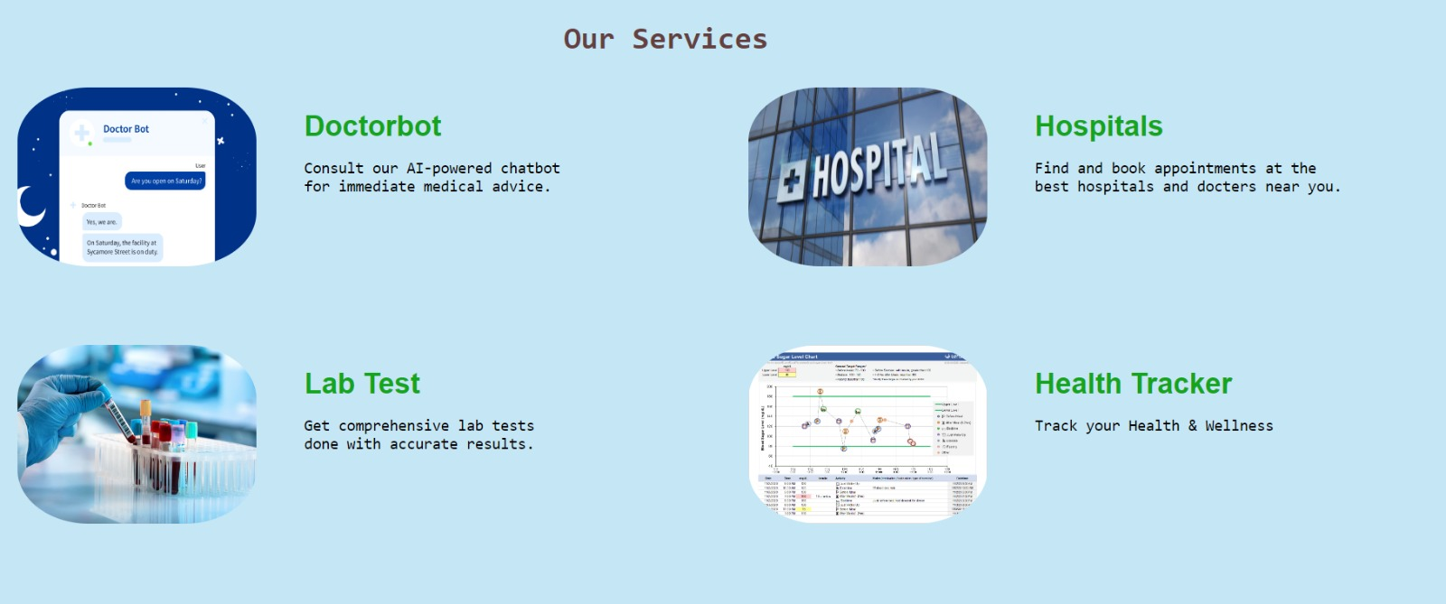

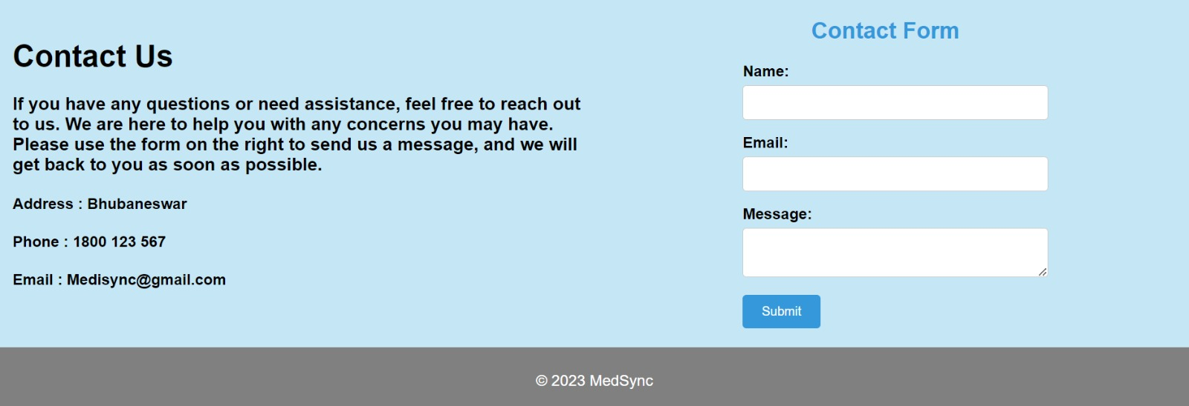

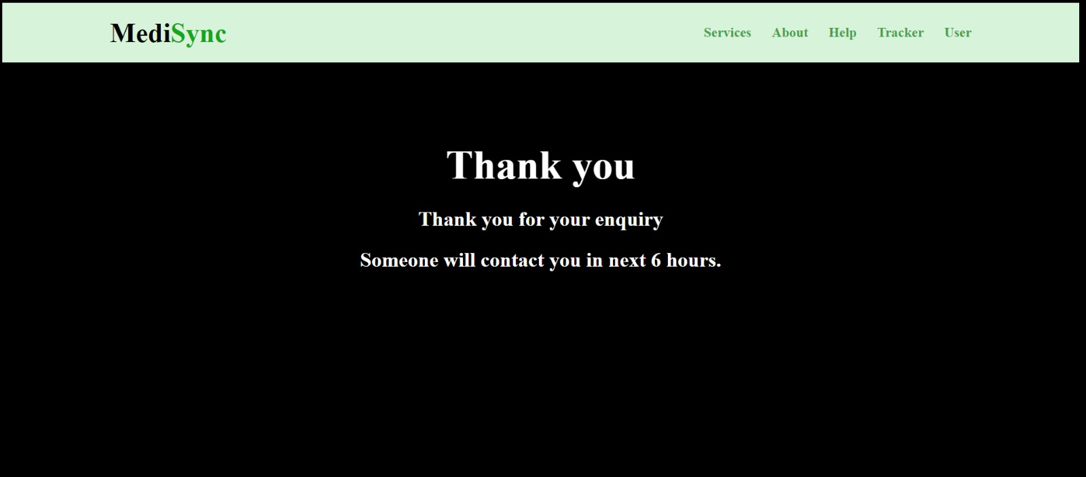

## 3.2 Database Interfaces

* **Entity Relation(ER) Diagram** -

## ERD

* **Scheema** -

|  |
| --- |
| User(U\_ID, U\_ADDRESS, F\_NAME, L\_NAME, AGE, UPH\_NO, D\_ID) |
| Doctor(D\_ID, DF\_NAME, DL\_NAME, SPECIALIZATION, FEES, EXPERIENCE, D\_ADDRESS, DPH\_NO) |
| Works For(D\_ID, H\_ID) |
| Hospital(H\_ID, H\_NAME, H\_ADDRESS) |
| Lab Test(T\_ID, T\_DATE, T\_NAME, NORMAL\_RANGE, RESULT, DETAILS, PREVIOUS\_RESULT, T\_COST, H\_ID) |
| Pay For(U\_ID, T\_ID) |

## Tables -

|  |  |  |  |  |  |  |
| --- | --- | --- | --- | --- | --- | --- |
| USER | | | | | | |
| U\_ID | U\_ADDRESS | F\_NAME | L\_NAME | AGE | UPH\_NO | D\_ID |
| 1001 | KOLKATA | ROHAN | DAS | 22 | 9847397399 | 101 |
| 1002 | BHUBANESHWAR | KUNAL | DASH | 21 | 9872385105 | 102 |
| 1003 | PATNA | PREM | BHARTI | 19 | 9026947156 | 102 |

|  |  |  |  |  |  |  |  |
| --- | --- | --- | --- | --- | --- | --- | --- |
| DOCTOR | | | | | | | |
| D\_ID | DF\_NAME | DL\_NAME | SPECIALIZATION | FEES | EXPERIENCE | D\_ADDRESS | DPH\_NO |
| 101 | RAJ | SHARMA | PEADIATRICS | 700 | 5 | MUMBAI | 9108799270 |
| 102 | ADITYA | ROY | CARDIOLOGIST | 1000 | 7 | KOLKATA | 9446710083 |
| 103 | RAVI | GUPTA | GENERAL SURGEON | 2000 | 12 | NEW DELHI | 9579778717 |

|  |  |
| --- | --- |
| WORKS UNDER | |
| D\_ID | H\_ID |
| 101 | 1 |
| 102 | 2 |
| 103 | 2 |

|  |  |  |
| --- | --- | --- |
| HOSPITAL | | |
| H\_ID | H\_NAME | H\_ADDRESS |
| 1 | APOLLO | BANGALORE |
| 2 | FORTIS | NOIDA |
| 3 | CK BIRLA | KOLKATA |

|  |  |  |  |  |  |  |  |  |
| --- | --- | --- | --- | --- | --- | --- | --- | --- |
| LAB TEST | | | | | | | | |
| T\_ID | T\_DATE | T\_NAME | NORMAL\_RANGE | RESULT | DETAILS | PREVIOUS\_RESULT | T\_COST | H\_ID |
| 512 | 11-10-2023 | HEMOGLOBIN | 13.8-17.2 | 14.5 | NORMAL | 14.8 | 300 | 1 |
| 556 | 10-10-2023 | LEUKOCYTE COUNT | 5000-10000 | 6500 | NORMAL | 5800 | 200 | 2 |
| 594 | 08-10-2023 | PLATELETS | 150000-450000 | 122000 | ABNORMAL | 157500 | 200 | 3 |

|  |  |
| --- | --- |
| PAY FOR | |
| U\_ID | T\_ID |
| 1001 | 556 |
| 1002 | 594 |
| 1003 | 512 |

## 3.3 Software Interfaces

* **Software Architecture -**

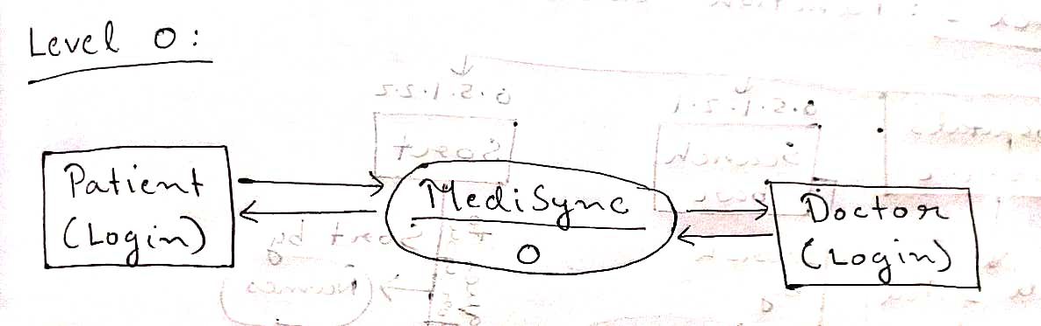

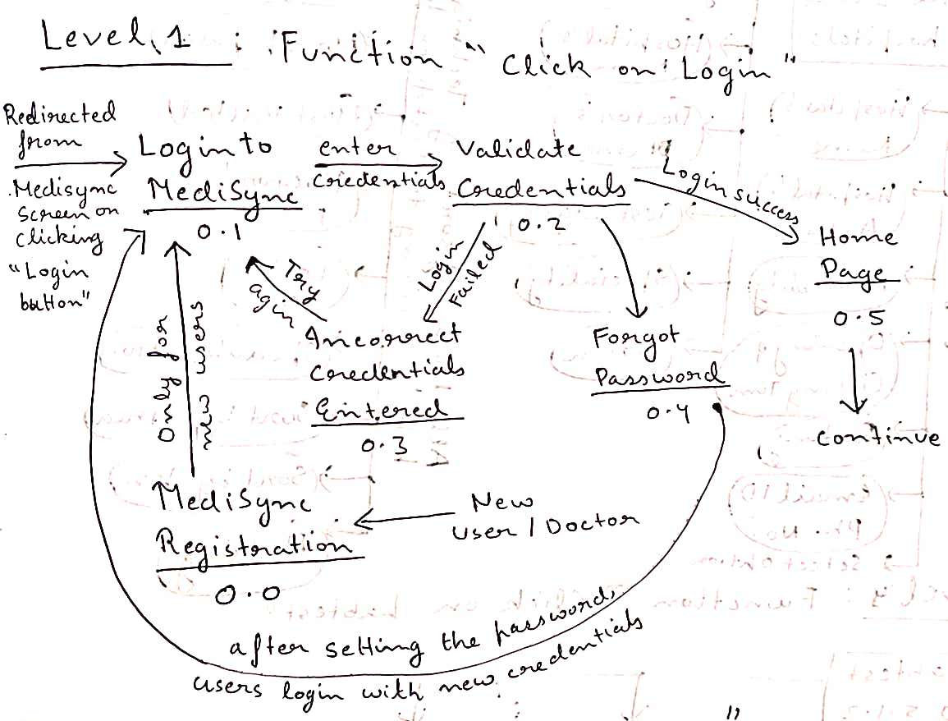

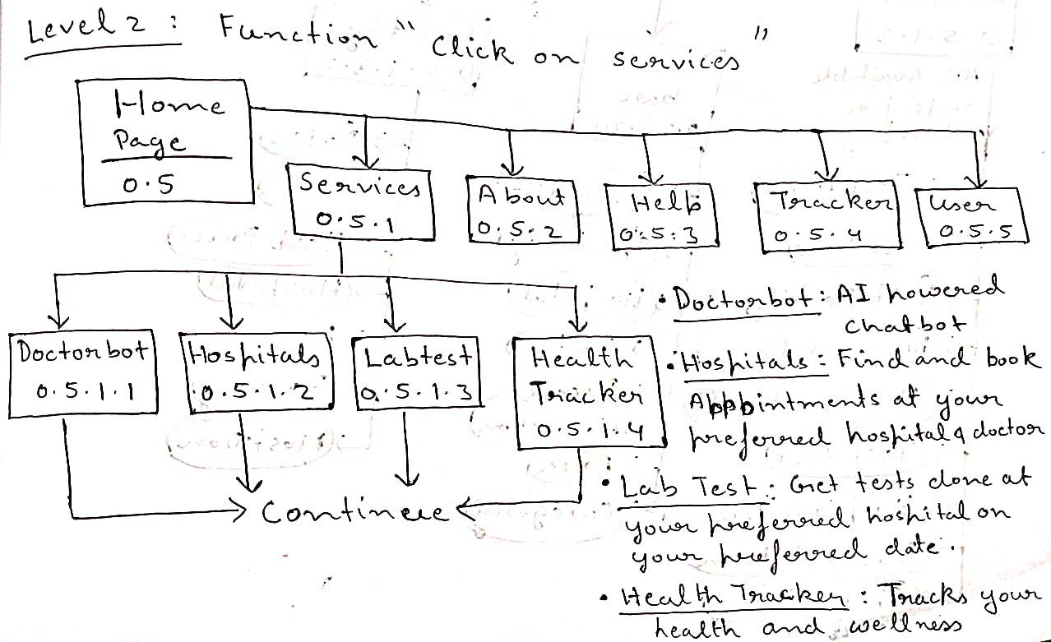

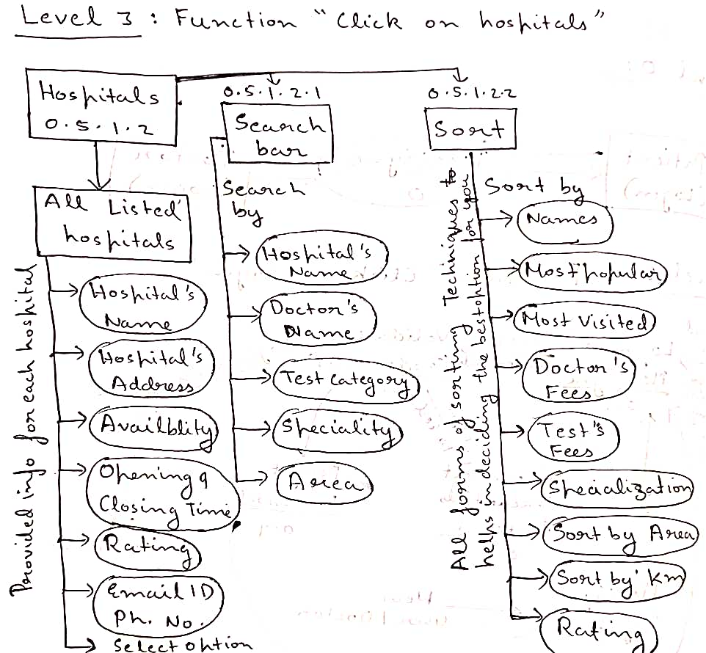

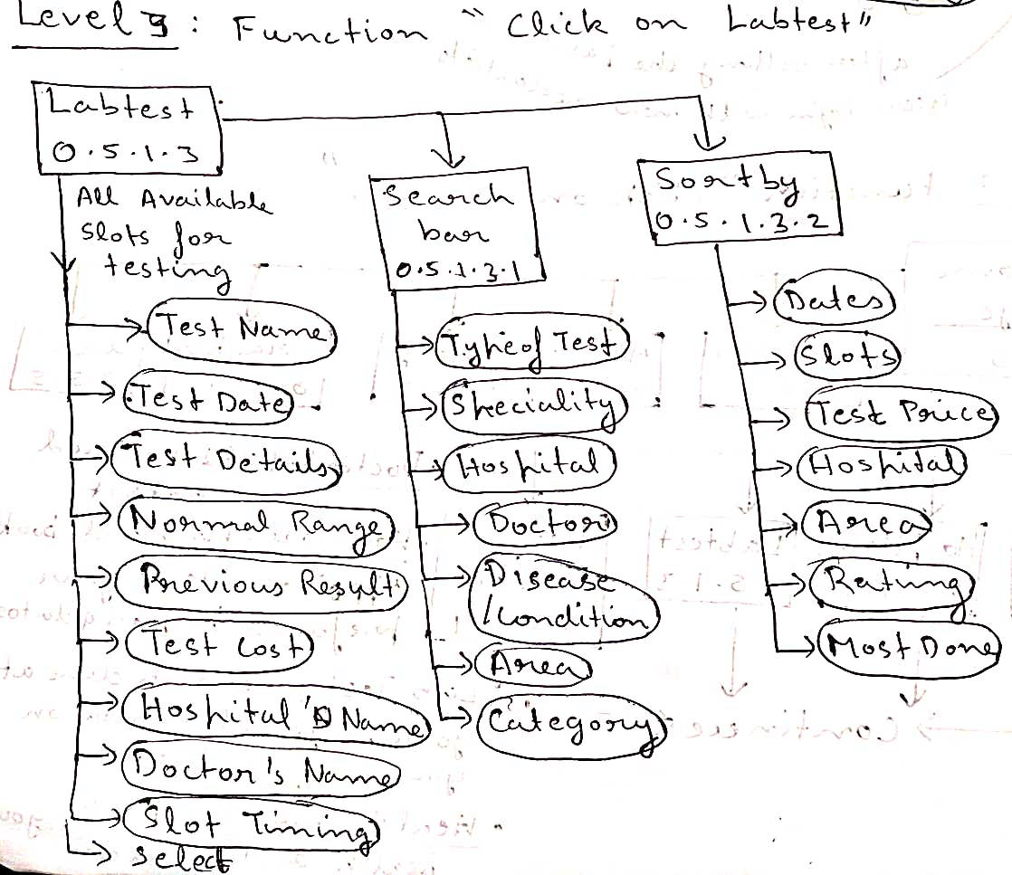

## 

## 3.4 Communications Interfaces (UML DIAGRAMS)

* **Use Case Diagram -**

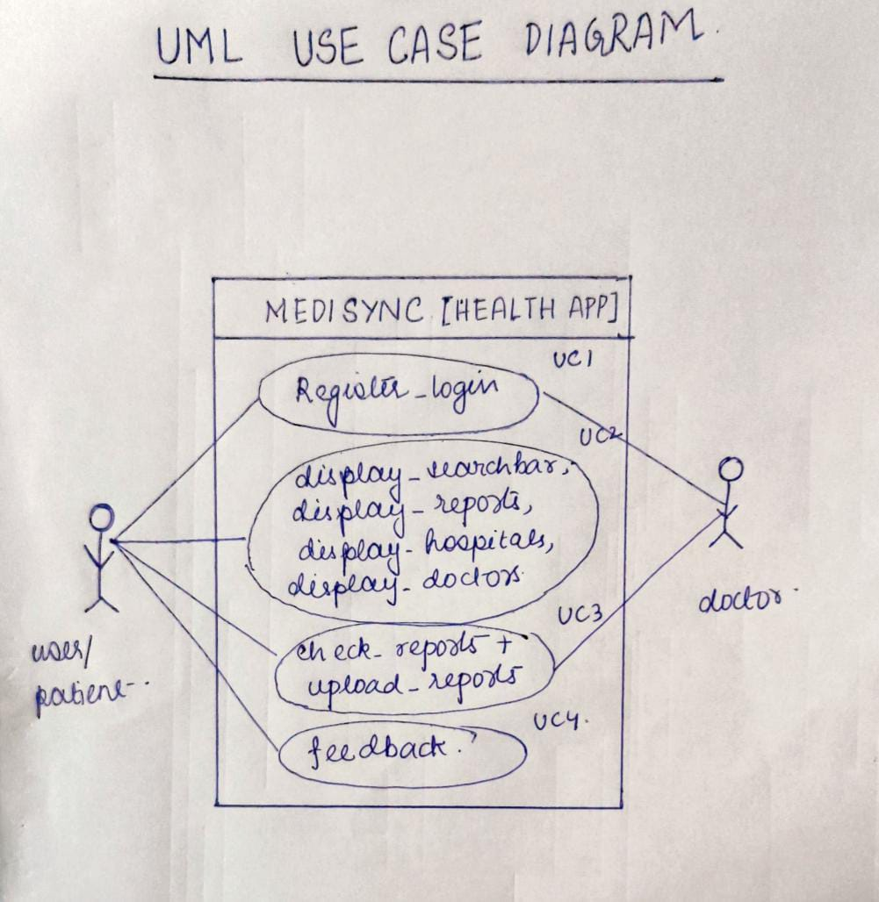

* **Class Diagram -**

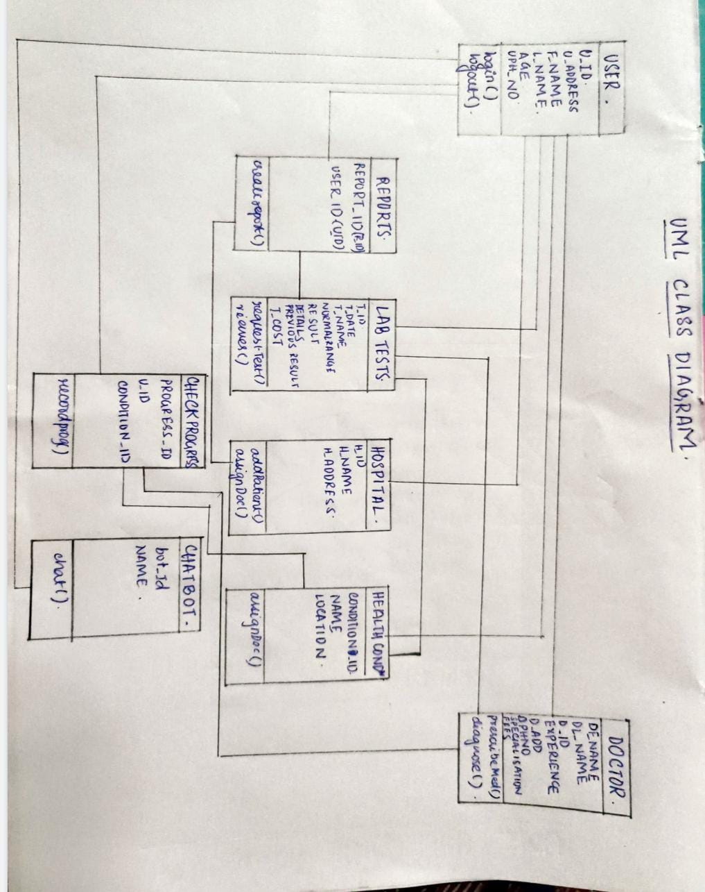

* **Sequence Diagram -**

**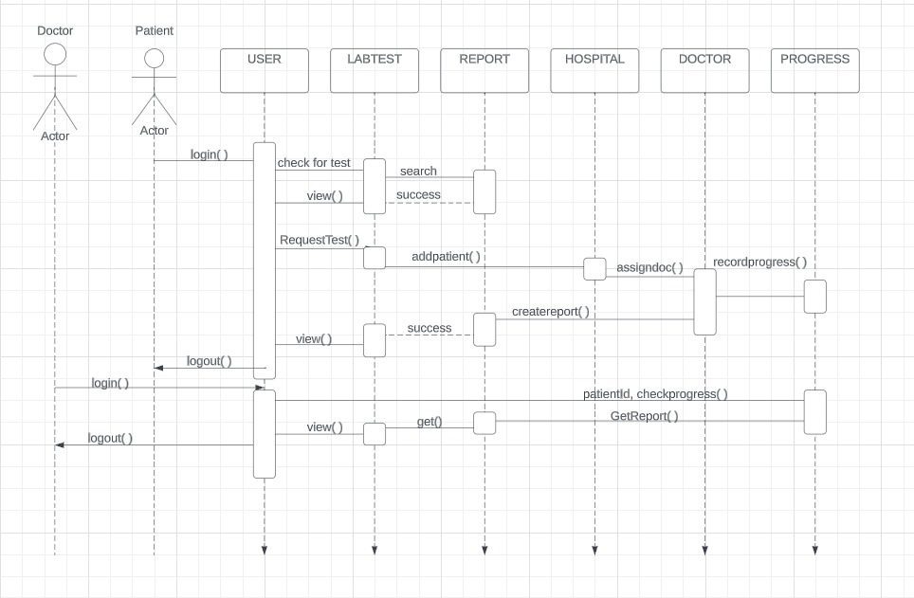**

# **System Features**

1. User Registration and Login:

- Users should be able to create accounts using email or social media accounts.

- Users should be able to log in with their registered credentials.

- The app should ensure the security of user credentials and data.

2. Profile Management:

- Patients and doctors should be able to create and manage their profiles with relevant information.

- Users should be able to edit their profile details.

3. Appointment Scheduling:

- Patients should be able to request appointments with doctors.

- Doctors should be able to accept, reject, or reschedule appointments.

- Users should receive notifications of appointment status changes.

4. Medical Record Access:

- Patients should be able to view and update their medical history.

- Doctors should have access to patient medical records during appointments.

5. Prescription Generation:

- Doctors should be able to generate digital prescriptions for patients.

- Prescriptions should include medication details, dosage instructions, and any notes.

6. Telehealth Services:

- The app should provide a secure platform for video consultations between patients and doctors.

- Users should be able to initiate and join video calls from within the app.

7. Secure Messaging:

- Patients should be able to send messages to their doctors for non-urgent queries.

- Doctors should be able to respond to patient messages.

8. Appointment Reminder:

- Users should receive reminders for upcoming appointments via push notifications or emails.

9. Search and Filters:

- Users should be able to search for doctors based on specialization, location, availability, etc.

10. Medication Reminders:

- The app should send medication reminders to patients according to their prescribed schedule.

11. Feedback and Ratings:

- Patients should be able to provide feedback and ratings for doctors and services.

12. Payment Integration:

- The app should facilitate secure payment processing for appointments, services, and medications.

13. Privacy and Security:

- The app should adhere to data protection regulations, ensuring patient data privacy.

- Sensitive medical information should be securely encrypted.

14. Localization:

- The app should support multiple languages for a diverse user base.

15. Offline Functionality:

- Basic features, like viewing appointments, should be accessible in offline mode.

- The app should sync data once the user is back online.

16. Integration with EHR Systems:

- The app should integrate with existing electronic health record systems to access patient histories.

17. Integration with Pharmacy and Labs:

- The app should integrate with pharmacy and laboratory services to facilitate medication orders and test results.

18. Accessibility Features:

- The app should include accessibility options for users with disabilities.

19. Technical Compatibility:

- The app should work on specified platforms (iOS, Android, web) and meet device specifications.

20. Data Backup and Recovery:

- The app should regularly back up user data and provide a way to recover it in case of data loss.

# 5. Other Nonfunctional Requirements

1. Performance:

- The app should respond to user interactions, such as opening the app or navigating between sections, within 2 seconds under typical load conditions to ensure a smooth user experience.

- The app should be able to handle peak usage times, such as during appointment reminders, without significant slowdowns.

- The time taken to upload and download medical documents should not exceed 5 seconds per document, ensuring efficient data transfer.

2. Security:

- User authentication must utilize industry-standard encryption protocols (e.g., HTTPS) to secure user login credentials and prevent unauthorized access.

- User medical records and sensitive health data should be encrypted both at rest and during transmission to protect against data breaches.

- The app must implement strict access controls, ensuring that only authorized healthcare professionals can view specific medical documents.

3. Reliability:

- The app should have an availability of 99.9%, allowing for maintenance windows and updates while minimizing user disruptions.

- In the event of server downtime, the app should display a user-friendly maintenance message, indicating when the service will be available again.

4. Scalability:

- The app's backend architecture should be designed with horizontal scalability in mind, allowing for the addition of more servers to accommodate increased user load.

- The database should be optimized to handle growing amounts of medical data without compromising performance.

5. Usability:

- The app's user interface should follow established design principles, such as clear navigation, consistent layout, and easily recognizable icons, to enhance usability.

- User onboarding should be intuitive, providing step-by-step guidance for setting up an account, uploading documents, and understanding health graphs.

6. Compatibility:

- The app should be compatible with the latest versions of iOS and Android operating systems, and also provide support for the two previous major versions.

- The user interface should adapt gracefully to different screen sizes and orientations to maintain a consistent user experience.

7. Notifications:

- Notifications for medical tests and appointments should be delivered using platform-specific notification services (e.g., Apple Push Notification Service, Firebase Cloud Messaging) to ensure reliability and timely delivery.

- Users should have the ability to set their preferred notification times and frequency.

8. Localization:

- The app's user interface should be fully localized, allowing users to switch between languages seamlessly.

- Location-based recommendations should take into account the user's current language and location settings to provide relevant information.

9. Data Backup and Recovery:

- Regular automated backups of user data should be performed on secure off-site servers to prevent data loss in the event of hardware failures or disasters.

- The app should offer a user-initiated data export feature, allowing users to create personal backups of their medical documents and health data.

10. Network Connectivity:

- The app should allow users to access previously synchronized data even when offline, ensuring that critical health information is available when needed.

- Changes made while offline should be stored locally and automatically synchronized with the server when a stable network connection is established.

11. Feedback and Reporting:

- The app should include a built-in feedback mechanism, enabling users to report bugs, suggest improvements, and provide general feedback directly from within the app.

- Feedback submitted by users should be collected, analyzed, and addressed in subsequent app updates.

12. Geolocation:

- The app should request user permission before accessing geolocation data, clearly explaining how and why this data will be used

- Recommendations for local checkup places should be based on real-time user input and reviews to provide accurate and up-to-date information.

1. Business Rule:

Users have full ownership and control over their medical documents and health data stored in the app. Users should be able to export, download, or delete their data at any time.

Rationale: Empowering users with control over their health information fosters trust and ensures compliance with data ownership and privacy regulations. Users should have the ability to manage their data as they see fit, aligning with principles of data autonomy and transparency.

**Appendix A: Health Glossary**

● Welcome to Appendix A of the HellSaver Health Survey App—an invaluable resource

providing you with a comprehensive glossary of health-related terms and concepts.

This glossary serves as a reference point to enhance your understanding of health

and well-being, enabling you to make informed decisions about your lifestyle and

overall wellness.

**A - BMI (Body Mass Index):** A measurement calculated using your weight and height to

determine if you are underweight, normal weight, overweight, or obese.

**B - Cardiovascular Health:** Refers to the condition of your heart and blood vessels,

including factors like blood pressure, cholesterol levels, and overall heart function.

**C - Digestive System:** The bodily system responsible for breaking down food, absorbing

nutrients, and eliminating waste.

**D - Hydration:** The process of maintaining proper fluid levels in the body to support

various functions and overall health.

**E - Metabolism:** The chemical processes that occur within the body to convert food into

energy.

**F - Nutrients:** Substances found in food that provide nourishment and support various

bodily functions.

**G - Physical Activity:** Any bodily movement that requires energy expenditure and

promotes overall fitness and well-being.

**H - Stress Management:** Techniques and strategies to effectively cope with and reduce

stress, promoting mental and emotional well-being.

**I - Sleep Hygiene:** Practices and habits that contribute to healthy sleep patterns and

better quality of sleep.

**J - Immune System:** The body's defense mechanism against infections and diseases,

composed of various cells and proteins.

**K - Chronic Conditions:** Long-term health conditions that require ongoing management,

such as diabetes, hypertension, or asthma.

**L - Mental Health:** The state of emotional, psychological, and social well-being that

affects how you think, feel, and act.

**M - Screen Time:** The amount of time spent using electronic devices like smartphones,

computers, and TVs.

**N - Vaccination:** The administration of vaccines to stimulate the immune system and

provide protection against specific diseases.

**O - Portion Control:** Managing the quantity of food consumed in a meal to promote

balanced nutrition and prevent overeating.

**P - Resilience:** The ability to adapt and cope with challenges, stressors, and setbacks in a

healthy and positive way.

**Q - Quitting Tobacco:** The process of discontinuing the use of tobacco products to

improve overall health and reduce associated risks.

**R - Rest and Recovery:** Allowing the body and mind time to recuperate and rejuvenate

through proper sleep and relaxation.

**S - Well-being:** The state of being comfortable, healthy, and happy, encompassing

physical, mental, and emotional aspects.

**T - Tracking Progress:** Monitoring and recording health-related behaviors, goals, and

outcomes to assess your journey toward better health.

**U - Vaccination:** The administration of vaccines to stimulate the immune system and

provide protection against specific diseases.

**V - Vaccination:** The administration of vaccines to stimulate the immune system and

provide protection against specific diseases.

**W - Water Intake:** The amount of water consumed daily to maintain hydration and

support bodily functions.

**X - X-ray:** A type of imaging that uses small amounts of radiation to create pictures of

the inside of the body.

**Y - Yoga and Meditation:** Practices that combine physical postures, breathing exercises,

and meditation to promote relaxation and well-being.

**Z - Zinc:** An essential mineral that plays a role in various bodily functions, including

immune support and wound healing.

This glossary is designed to empower you with knowledge and understanding, enabling

you to make informed choices about your health and well-being. As you navigate the

journey to a healthier you, HellSaver Health Survey App is here to support and guide you

every step of the way.

Tagline: Empowering Wellness, Averting Descent

**Appendix B: Insightful Analysis Models**

Welcome to Appendix B of HellSaver—an exploration of intricate analysis models

designed to illuminate the complex facets of health. These models offer you a structured

lens through which you can assess your

**Appendix A: Health Glossary**Welcome to Appendix A of the HellSaver Health Survey App—an invaluable resource

providing you with a comprehensive glossary of health-related terms and concepts. This

glossary serves as a reference point to enhance your understanding of health and well-

being, enabling you to make informed decisions about your lifestyle and overall wellness.

**A - BMI (Body Mass Index):** A measurement calculated using your weight and height to

determine if you are underweight, normal weight, overweight, or obese.

**B - Cardiovascular Health:** Refers to the condition of your heart and blood vessels,

including factors like blood pressure, cholesterol levels, and overall heart function.

**C - Digestive System:** The bodily system responsible for breaking down food, absorbing

nutrients, and eliminating waste.

**D - Hydration:** The process of maintaining proper fluid levels in the body to support

various functions and overall health.

**E - Metabolism:** The chemical processes that occur within the body to convert food into

energy.

**F - Nutrients:** Substances found in food that provide nourishment and support various

bodily functions.

**G - Physical Activity:** Any bodily movement that requires energy expenditure and

promotes overall fitness and well-being.

**H - Stress Management:** Techniques and strategies to effectively cope with and reduce

stress, promoting mental and emotional well-being.

**I - Sleep Hygiene:** Practices and habits that contribute to healthy sleep patterns and

better quality of sleep.

**J - Immune System:** The body's defense mechanism against infections and diseases,

composed of various cells and proteins.

**K - Chronic Conditions:** Long-term health conditions that require ongoing management,

such as diabetes, hypertension, or asthma.

**L - Mental Health:** The state of emotional, psychological, and social well-being that

affects how you think, feel, and act.

**M - Screen Time:** The amount of time spent using electronic devices like smartphones,

computers, and TVs.

**N - Vaccination:** The administration of vaccines to stimulate the immune system and

provide protection against specific diseases.

**O - Portion Control:** Managing the quantity of food consumed in a meal to promote

balanced nutrition and prevent overeating.**P - Resilience:** The ability to adapt and cope with challenges, stressors, and setbacks in a

healthy and positive way.

**Q - Quitting Tobacco:** The process of discontinuing the use of tobacco products to

improve overall health and reduce associated risks.

**R - Rest and Recovery:** Allowing the body and mind time to recuperate and rejuvenate

through proper sleep and relaxation.

**S - Well-being:** The state of being comfortable, healthy, and happy, encompassing

physical, mental, and emotional aspects.

**T - Tracking Progress:** Monitoring and recording health-related behaviors, goals, and

outcomes to assess your journey toward better health.

**U - Vaccination:** The administration of vaccines to stimulate the immune system and

provide protection against specific diseases.

**V - Vaccination:** The administration of vaccines to stimulate the immune system and

provide protection against specific diseases.

**W - Water Intake:** The amount of water consumed daily to maintain hydration and

support bodily functions.

**X - X-ray:** A type of imaging that uses small amounts of radiation to create pictures of

the inside of the body.

**Y - Yoga and Meditation:** Practices that combine physical postures, breathing exercises,

and meditation to promote relaxation and well-being.

**Z - Zinc:** An essential mineral that plays a role in various bodily functions, including

immune support and wound healing.

This glossary is designed to empower you with knowledge and understanding, enabling

you to make informed choices about your health and well-being. As you navigate the

journey to a healthier you, HellSaver Health Survey App is here to support and guide you

Appendix B: Insightful Analysis Models

Welcome to Appendix B of HellSaver—an exploration of intricate analysis models

designed to illuminate the complex facets of health. These models offer you a structured

lens through which you can assess your well-being and take proactive steps to prevent

potential health challenges.

Appendix C: Evolving ExplorationsIn Appendix C, we present a space that awaits the unveiling of future enhancements and

expansions. Here, you'll find upcoming features, insights, and additions that will further

enhance your journey towards optimal health.

In the realm of health, knowledge is the key to prevention, and HellSaver is committed to

providing you with the tools you need to rise above challenges and embrace a future

filled with vitality.

Appendix C stands as a canvas of anticipation, reserved for upcoming expansions that will

further elevate your grasp of health preservation. This evolving space ensures you're

continually armed with the latest knowledge and strategies.

Within the realm of health, the trajectory toward undesirable states can often be

disrupted through informed understanding and proactive measures. HellSaver is your

stalwart companion, empowering you to ascend towards vitality and well-being.